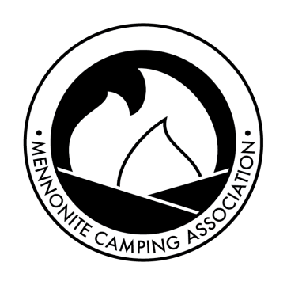
A voluntary fellowship within the Anabaptist tradition of
camps, retreat centers, camp associations, and individuals.

PURPOSE
 Since 1960, Mennonite Camping Association has been a clearinghouse for directing and promoting Christian camping among Mennonite conferences and congregations throughout Canada and the United States.

 MCA continues to strengthen an outdoor ministry whose beginnings among Anabaptists in North America date back
to the 1920s.

 Membership in MCA provides a united voice for addressing camping concerns to church agencies, and in turn, gives church agencies a channel for relating to the retreat and camping ministry.

 Supplementing local congregational nurture, Christian camps and retreat centers band together through MCA to promote quality spiritual experience in outdoor ministry.
MEMBERSHIP BENEFITS
 Listing on the MCA web site
www.mennonitecamping.org includes brief description of your camp/retreat ministry with a link to your web site.

 Shared promotion of member camps at church wide gatherings (booths at national youth and adult conventions, advertisements in Mennonite publications, etc.)

 Receive a registration discount for the MCA Bi-national Conventions & Regional gatherings.

 Receive a discount on meals and lodging for the Values-based Leadership program at Laurelville (subject to change).

 Submit to and receive monthly issues of the MCA newsletter, Natural Links, the voice of the association. Articles include: features on sister camps, resources on various aspects of the camp/retreat ministry, calendar of events, job openings and more.

 Participate in an influential fellowship which works toward goals you share and feel deeply about.

MCA CONTACT INFORMATION

Chris Pot, President
chrispot@hiddenacres.ca
mennonitecamping@gmail.com
SPONSORED AND SUPPORTED
by the Mennonite faith family including:

   Mennonite Church Canada
Mennonite Church USA

MCA WELCOMES YOUR TAX-DEDUCTIBLE CONTRIBUTIONS

If MCA and Christian camping have touched your life in a special way and you want to see the ministry of camping remain strong and vibrant, we encourage you to consider giving to MCA. For individuals or camps who want a tax-deductible receipt for their donations:

Canada – We encourage Canadian donors to make donations directly to a specific Canadian Mennonite camp. Mennonite Camping Association can no longer accept donations through Mennonite Church Canada.

United States - Make check payable to Mennonite Church USA, designated for Mennonite Camping
Association.
Send to: Mennonite Church USA
Attn: Mennonite Camping Association
3145 Benham Ave., Suite 1
Elkhart IN 46517

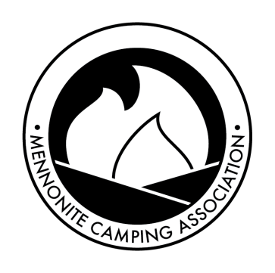
Please respond by February 26, 2021
to continue to receive membership benefits.

Two years of membership for the price of one! If you paid in 2020, you do not need to pay in 2021!

□ Camp/Retreat Membership (complete individual information below)
Name of Member Organization: Mailing Address:

General Email: Executive Director:
Phone: Email:

Check One Annual Fee Operating Budget Memberships Included
 |  | United States and Canada
□ | $100 US/Canadian | under $50,000
□ | $175 US/Canadian | $50,000-$100,000
□ | $225 US/Canadian | $100,000-$500,000
□ | $300 US/Canadian | $500,000-$750,000.
□ | $350 US/Canadian | over $750,000

Membership is extended to all staff and board members.

□ Individual Membership(s) additional organizational or interested individuals
(complete individual information below)
$15 US/Canadian Individual
$12 US/Canadian College and Seminary Students

□ Institutional Membership - $100.00 US (colleges, seminaries, businesses, etc.)
Name of Institution/Individual: Mailing Address:

Email:

Phone:

Please note: Natural Links, the MCA e-newsletter, will be mailed to the executive director and general camp email at the email addresses given. The executive director is encouraged to disperse each issue to board and staff.

Please note: Membership checks should be payable to Mennonite Camping Association.

Organizational Fee $ ________ _

Individual Fees $ ________ _

Institutional Fees $ ________ _

Donation Enclosed $ ________ _
(USA donations to MCA should be payable to Mennonite Church USA; Canadian donations should be sent directly to camps.)

Total Enclosed $ ________ _
*Fees accepted in either US or Canadian dollars.

1 Please make a copy for your records.

2 Mail with check to cover membership fees*
payable to:

Mennonite Camping Association
Olivia Bartel, Member Relations Coordinator
c/o Camp Mennoscah
PO Box 65
Murdock, KS 67111

